Massage Therapy Health History Intake Form

Name: _________________________________ DOB: _________________________

Phone #: ______________________________ Occupation: ____________________

Address: __________________________________________________________________________

__________________________________________________________________________

Email: ___________________________________

Emergency Contact: ___________________ Relationship: ___________ Phone #: ___________

How did you hear about us? ______________________________

Have you had Massage Therapy in the Past? Y/N

Are you being treated by any other health practitioners? ____________________

Are you currently pregnant? Y/N

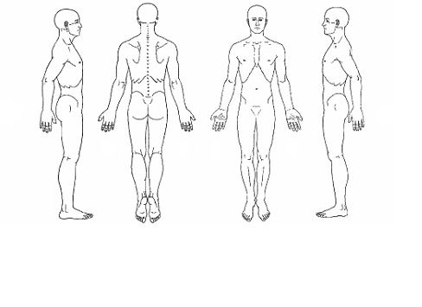Reason for today’s visit:

______________________________

______________________________

______________________________

______________________________

______________________________

______________________________

Please Indicate conditions you are experiencing or have experienced:

Cardiovascular

High Blood Pressure

Low Blood Pressure

Heart Disease

Varicose Veins

Bruise Easily

Other _________

Digestive/Urinary

Crohns/Colitis

Ulcers

Liver

Kidney

Other _________

Respiratory

Chronic Cough

Shortness of Breath

Bronchitis

Asthma

Emphysema

Other _________

Muscle/Joint

Muscle Strain

Ligament Sprain

Tendonitis

Bursitis

Arthritis

Osteoporosis

Herniated Disc

Scoliosis

Dislocation

Fracture

Other _________

Head & Neck

Headaches/Migraines

Whiplash

Jaw Pain

Ear Pain/Hearing Loss

Vision Loss

Other _________

Skin

Eczema

Psoriasis

Other _________

Women

Endometriosis

Menopausal Concerns

Hysterectomy

Other __________

Other Conditions

Diabetes

Allergies

Cancer

Fibromyalgia

Multiple Sclerosis

Epilepsy

MVA

Date: ________

Please list any Surgeries you’ve had:

_____________________________________________________________________________________

Please list any medication you are currently taking:

____________________________________________________________________________________

Signature: _______________________ Date: ________________________

*\*An accurate health history is important to ensure that it is safe to receive a massage therapy treatment. All information given before, during, and after treatments will be held in strict confidence. You will be asked to provide written authorization for release of any information. You will be required to update your health history on a yearly basis.*